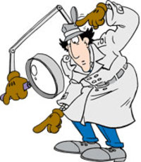**Natural Resources Inspection**

**Directions:** At each station, examine the picture or artifact. Decide what kind of natural resource it is or what kind of resource it is made of (renewable, non-renewable, perpetual, or potential). Then, defend your answer by explaining why.

|  |  |  |
| --- | --- | --- |
| **What is it?** | **What kind of resource?** | **What makes it that kind of resource?** |
| **1.** |  |  |
| **2.** |  |  |
| **3.** |  |  |
| **4.** |  |  |
| **5.** |  |  |
| **6.** |  |  |
| **7.** |  |  |
| **8.** |  |  |
| **9.** |  |  |
| **10.** |  |  |
| **11.** |  |  |
| **12.** |  |  |