**Regions of Utah**  Name ___________________________Date_________Period _____

Use pages 10-15 on Utah’s land regions in your textbook. Use the information from these pages and activity we did in class to fill in the boxes below.

**Major Landforms:**

**Economy:**

**Weather:**

**coo**

**Other interesting info:**

**Natural Resources?**

**Rocky Mountain Region**

**Things to do/visit:**

**Major Landforms:**

**Great Basin 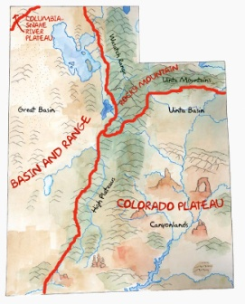 Colorado Plateau**

**Weather:**

**coo**

**Weather:**

**Natural Resources**

**Economy:**

**Things to do/visit:**

**Major landforms:**

**Things to do/visit:**

**Natural Resources**

**Other interesting info:**

**Other interesting info:**

**Economy:**